

**University of Petroleum and Energy Studies, Dehradun**

**Advanced Database Management Systems**

**Lab File**

Semester IV

By:

NAME – PRANJAL TRIPATHI

COURSE- B- TECH CSE (BAO)

BATCH – 01

ROLL NUMBER - R2142210964

SAI ID- 500096030

EXPERIMENT- 04

Title: 4. Use of Inbuilt functions and relational algebra operation

1. Create the following two tables (EMP and DEPT)

EMP TABLE

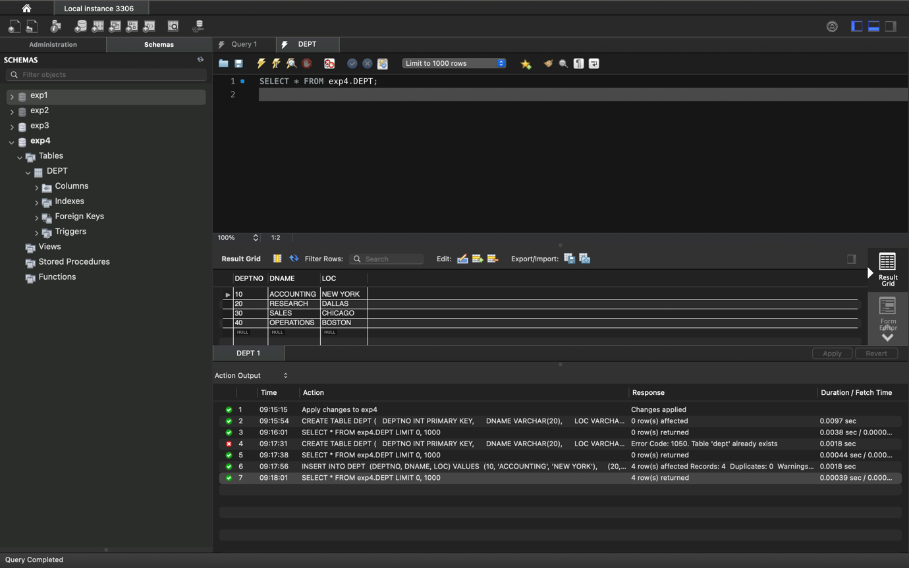

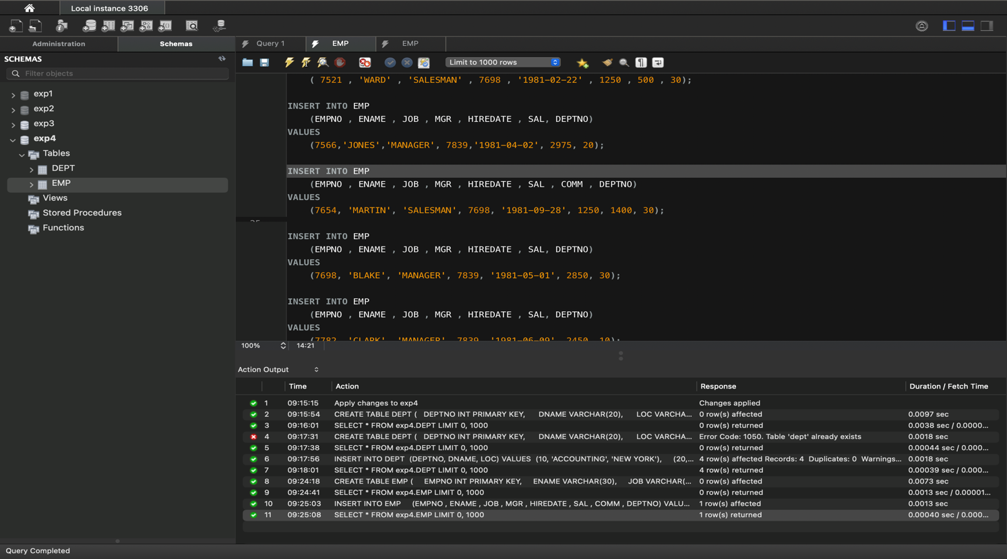

2- Write the Nested Queries for the following queries.

* List the details of the emps whose Salaries more than the employee BLAKE*/

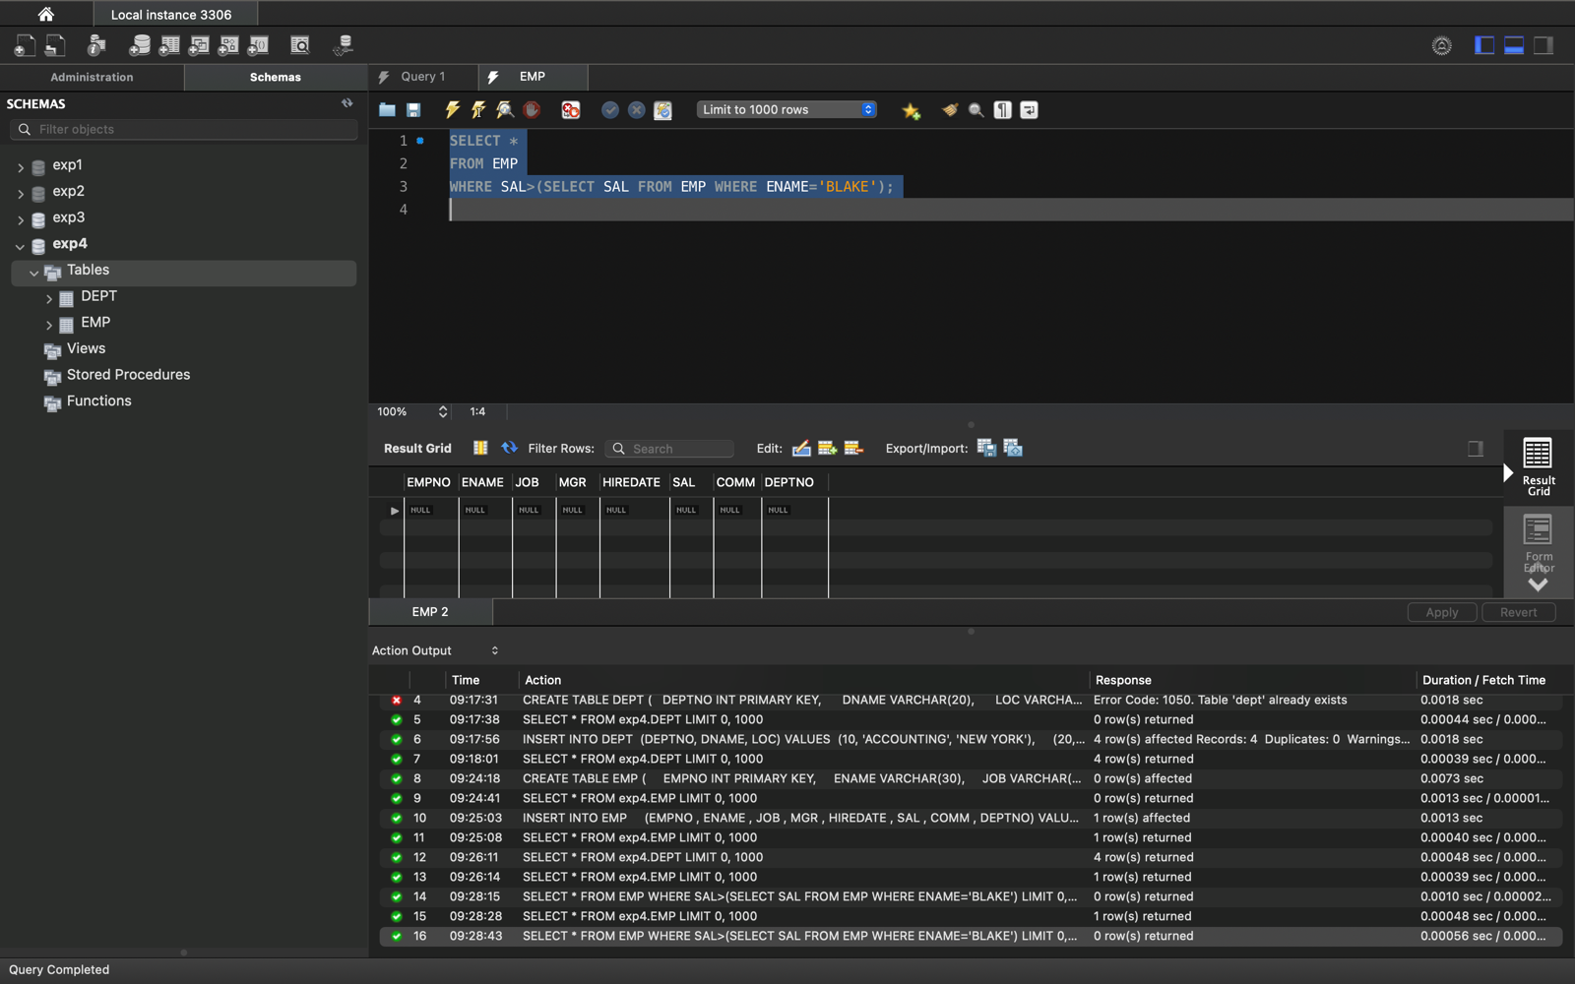

* List the emps whose Jobs are same as ALLEN.*/ 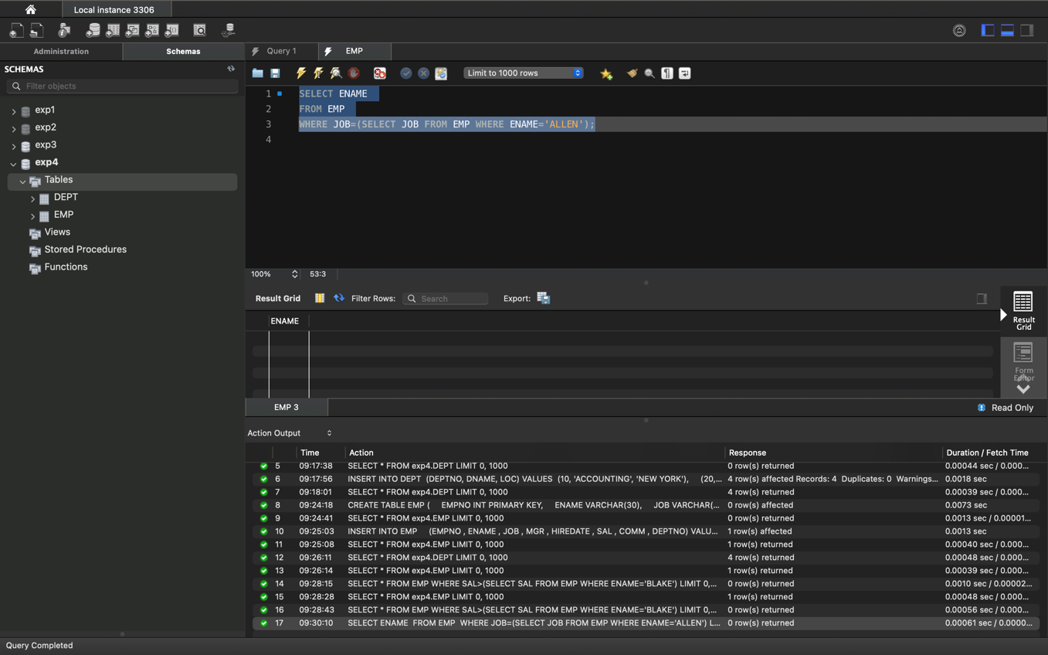
* List the Emps whose Sal is same as FORD or SMITH in desc order of Names. */

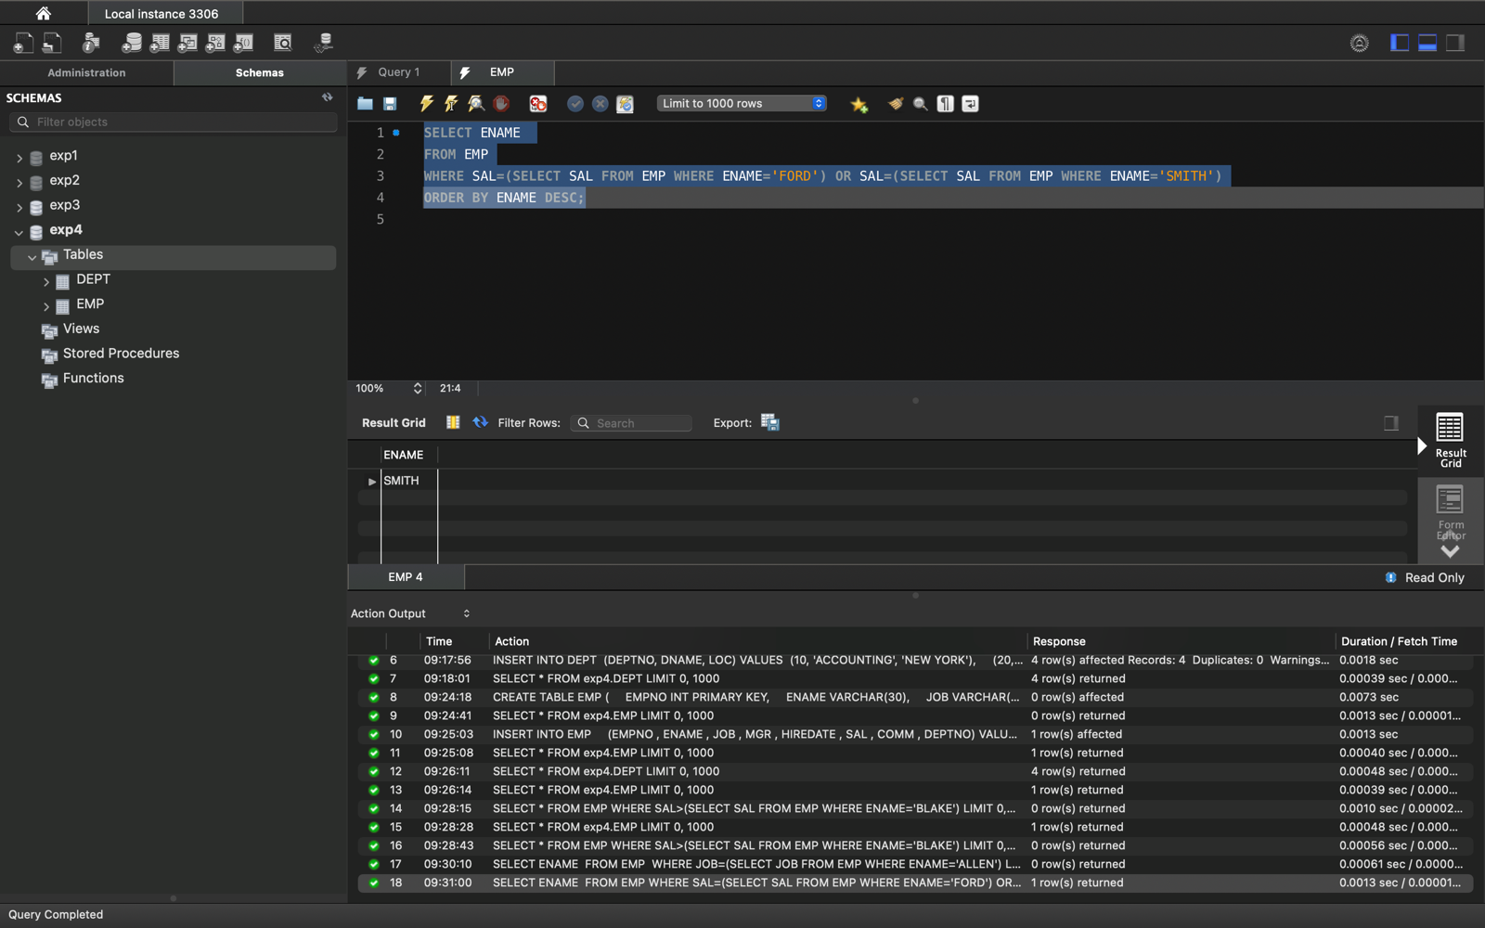

* List the emps Whose Jobs are same as MILLER or Sal is more than ALLEN.*

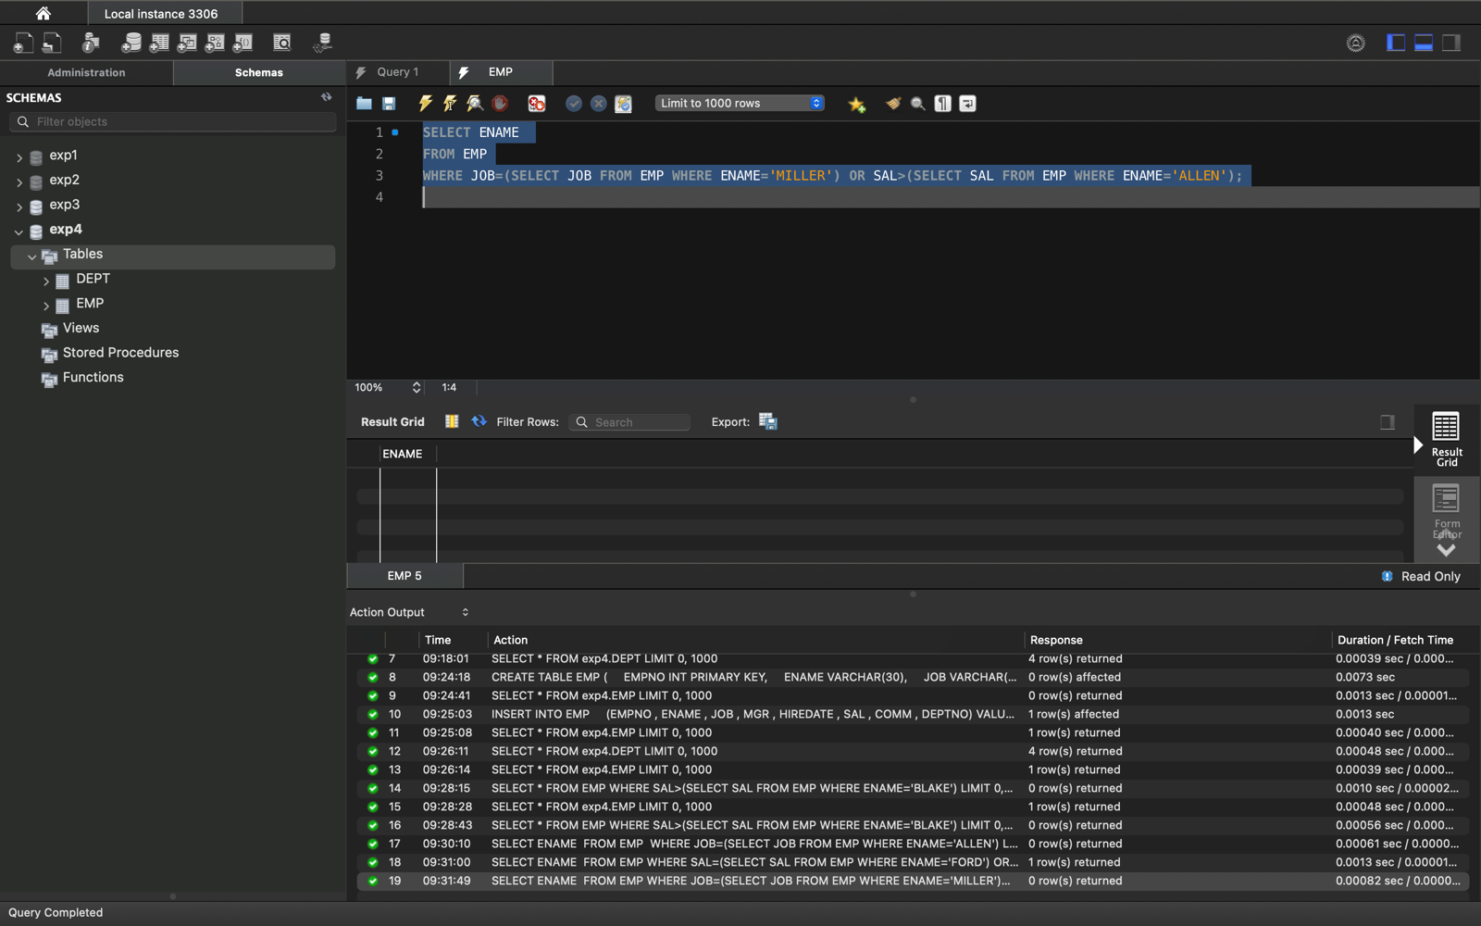

* Find the highest paid employee of sales department.

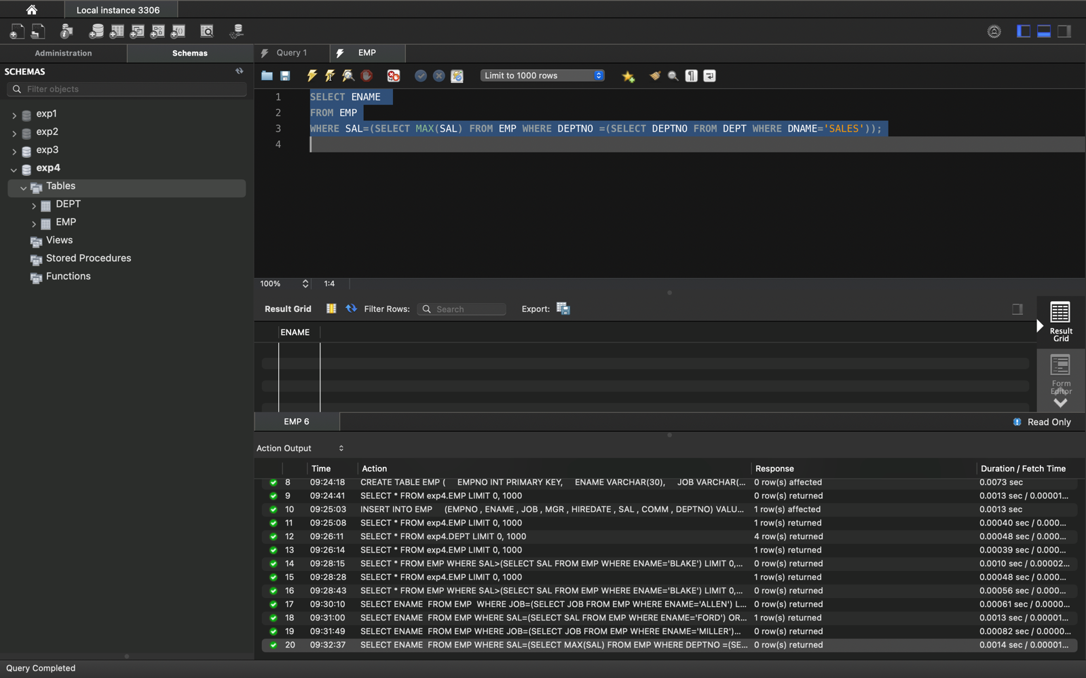

* List the employees who are senior to most recently hired employee working under king. */

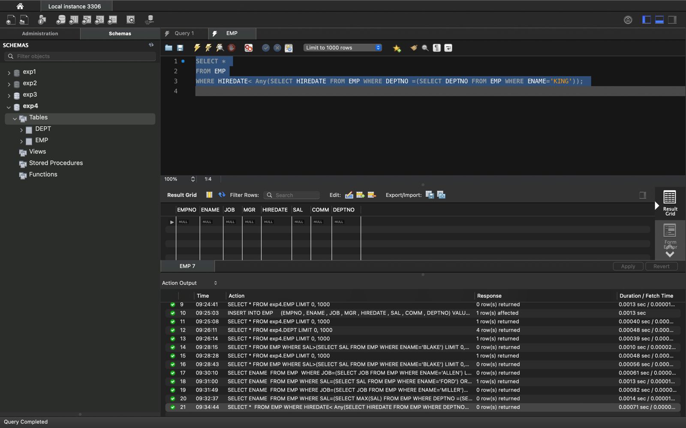

* List the names of the emps who are getting the highest sal dept wise.*/

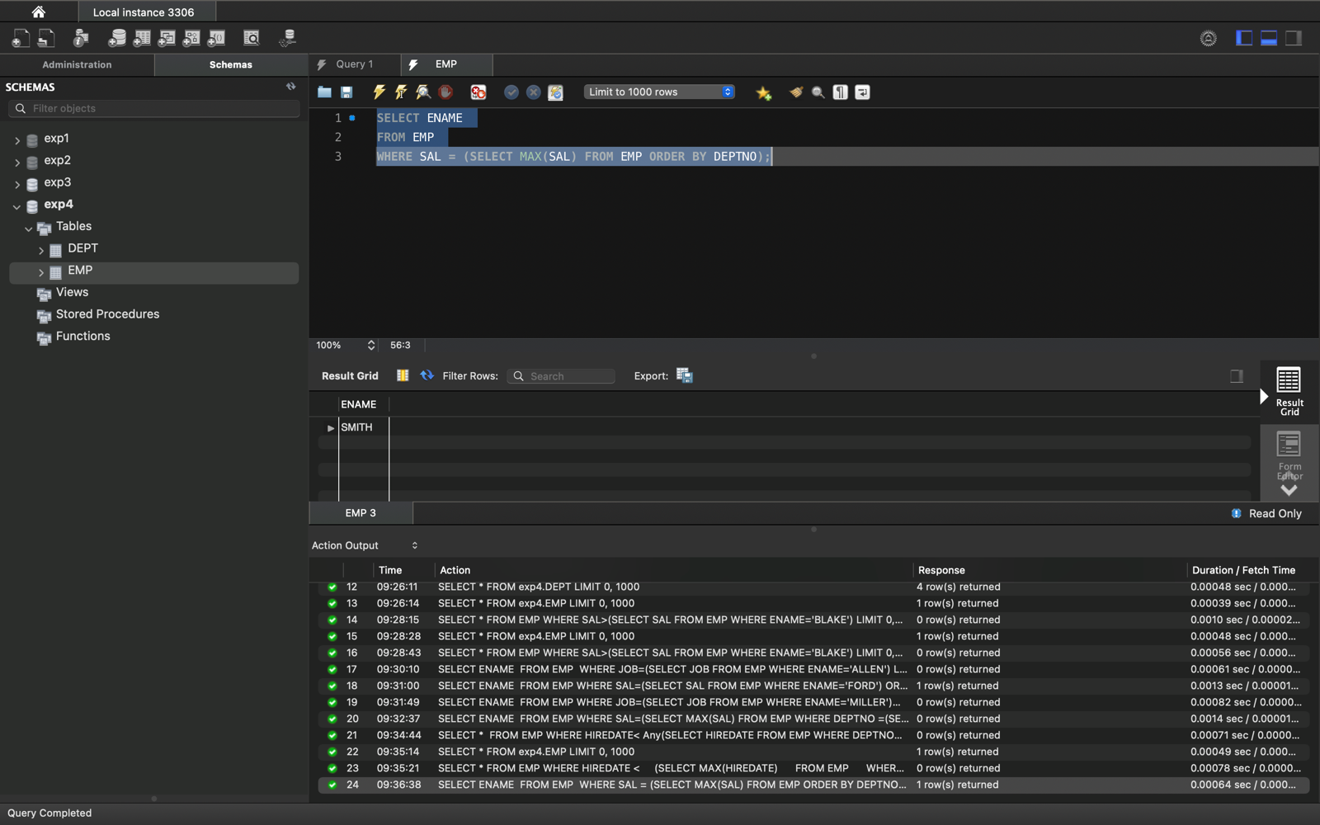

* List the emps whose sal is equal to the average of max and minimum*/

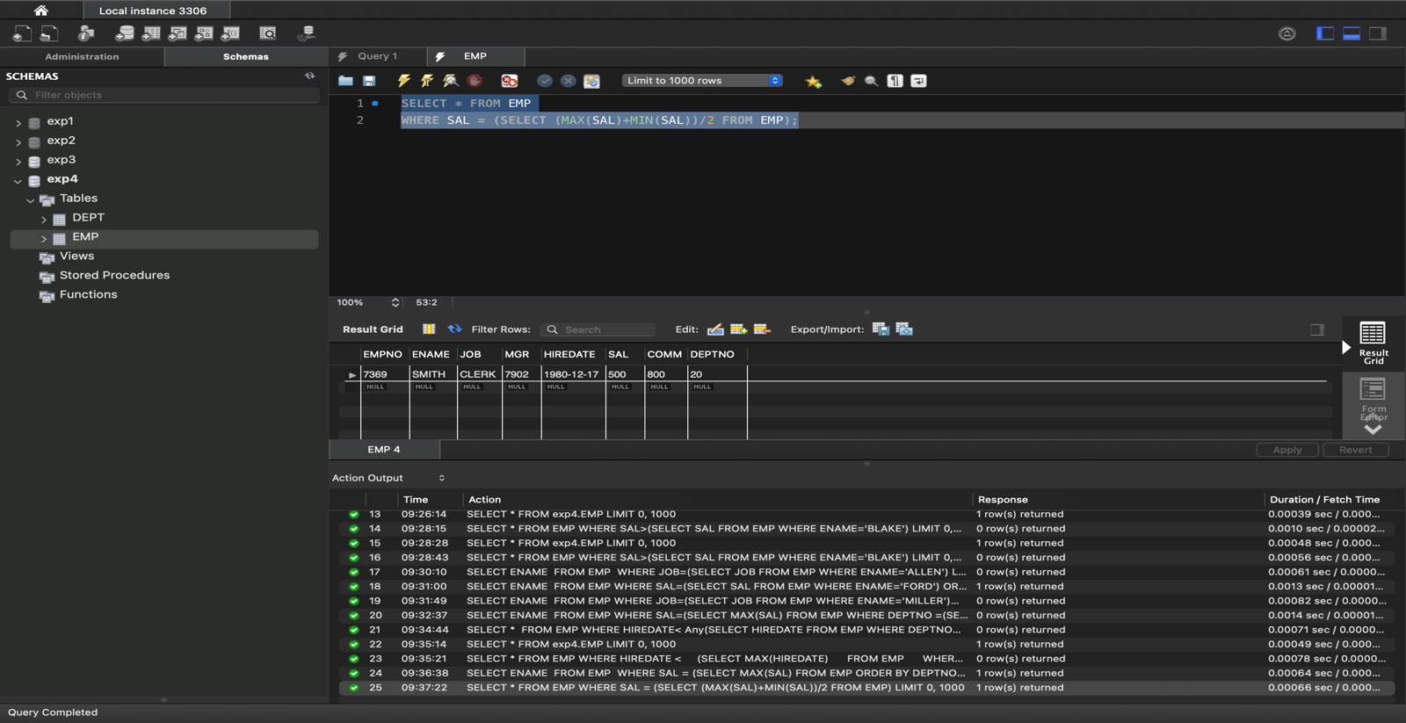

* List the emps who joined in the company on the same date.*/

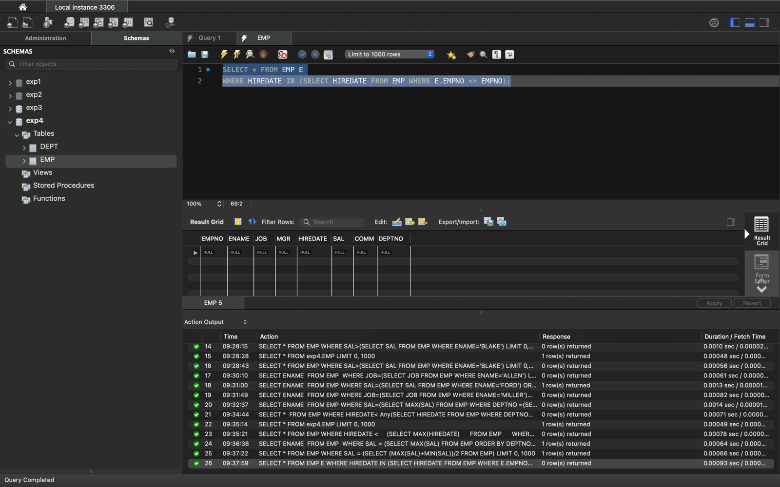

* Find out the emps who joined in the company before their Managers*/

